

Safety Data Sheet
Revision Date: 2023-09-18
- Product and company identification

Product Name: Zinc nitrate
Identification: Zinc nitrate solution
Recommended use: Fertilizer, only use as directed
Details of Supplier:
Hygrotech Properties (Pty) Ltd, 1 Gerard Braak Street, Pyramid, Pretoria, 0120
Emergency Telephone numbers:
Griffon Poison Information Centre: 082 446 8946
Hygrotech Head Office: 012 545 8000 (o/h)

- Hazard(s) identification

Classification of the substance or mixture
This product is classified as hazardous according to the criteria in South Africa - GHS classification and labelling of chemicals – SANS10234 and the Regulations for Hazardous Chemical Agents - 2021.

GHS Classification

Hazard Class | Category | Hazard Statement Number
Oxidising Liquid | 2 | H272
Skin Corrosion/Irritation | 2 | H315
Serious Eye Damage/Irritation | 2 | H319
STOT SE | 3 | H335
Aquatic Toxicity Acute | 1 | H400
Aquatic Toxicity Chronic | 2 | H411

Label Elements

Pictograms:
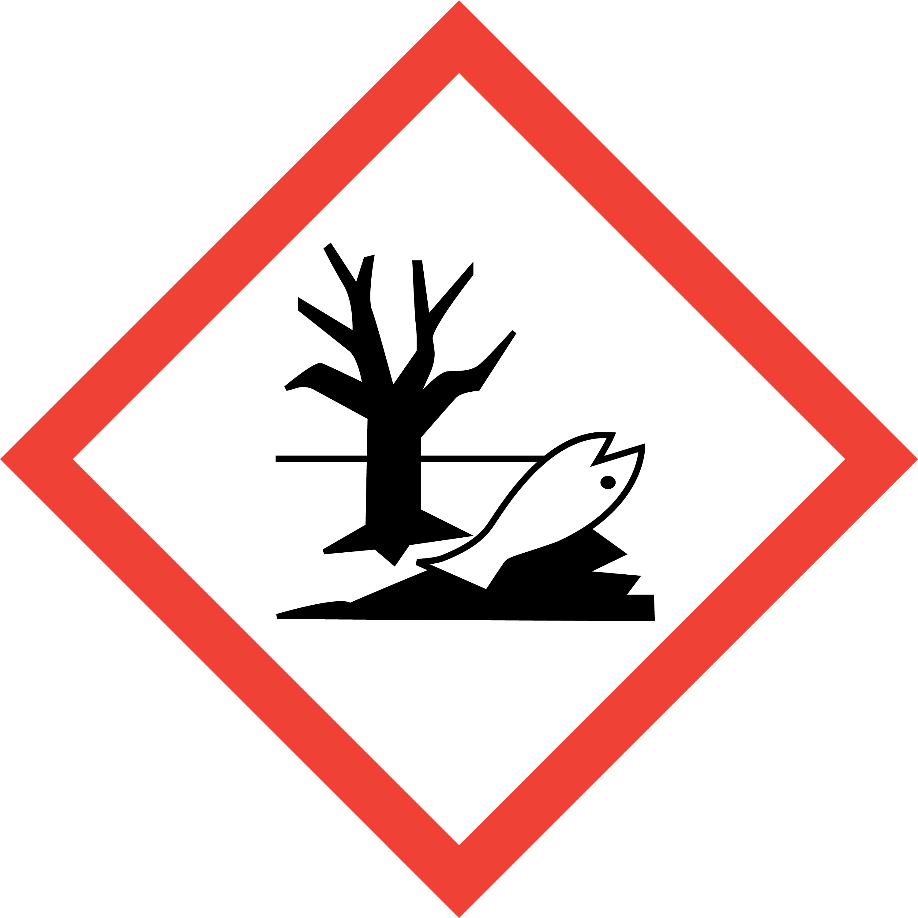
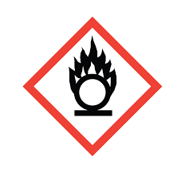
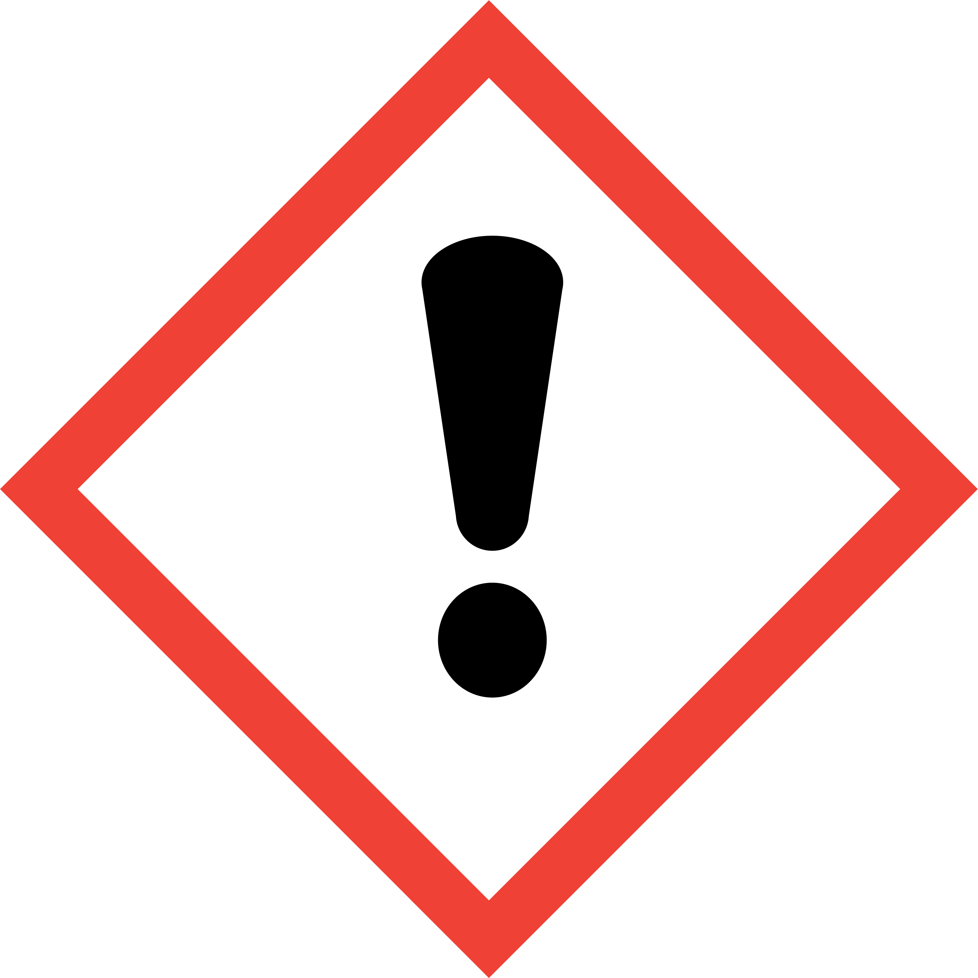

Signal Word:
Danger.

Hazard Statements:

Statement Number | Hazard Statement
H272 | May intensify fire; oxidiser
H315 | Causes skin irritation.
H319 | Causes serious eye irritation.
H335 | May cause respiratory irritation.
H400 | Very toxic to aquatic life.
H411 | Toxic to aquatic life with long lasting effects.

Precautionary Statements:
General -
Statement Number | Precautionary Statement
P101 | If medical advice is needed, have product container or label at hand.
P102 | Keep out of reach of children.
P103 | Read carefully and follow all instruction.

Prevention -
Statement Number | Precautionary Statement
P210 | Keep away from heat, hot surfaces, sparks, open flames, and other ignition sources. No smoking.
P220 | Keep away from clothing and other combustible materials.
P261 | Avoid breathing fumes/mist/vapours/spray.
P264 | Wash hands and face thoroughly after handling.
P271 | Use only outdoors in a well-ventilated area.
P273 | Avoid release to the environment.
P280 | Wear protective gloves, protective clothing, eye protection, and face protection.
P264 + P265 | Wash hands and face thoroughly after handling. Do not touch eyes.

Response -
Statement Number | Precautionary Statement
P319 | Get medical help if you feel unwell.
P391 | Collect spillage.
P302 + P352 | IF ON SKIN: Wash with plenty of water.
P304 + P340 | IF INHALED: Remove person to fresh air and keep comfortable for breathing.
P332 + P317 | If skin irritation or rash occurs: Get medical help.
P337 + P317 | If eye irritation persists: Get medical help.
P362 + P364 | Take off contaminated clothing and wash it before re-use.
P370 + P378 | In case of fire: Use the available fire fighting equipment to extinguish the fire.
P305 + P351 + P338 | IF IN EYES: Rinse cautiously with water for several minutes. Remove contact lenses, if present and easy to do. Continue rinsing.

Storage -
Statement Number | Precautionary Statement
P403 + P233 | Store in a well-ventilated place. Keep container tightly closed.

Disposal -
Statement Number | Precautionary Statement
P501 | Dispose of contents/container to an approved hazardous waste facility in accordance with local and national regulations.

Other Hazards
None known for the product.
Note: Contact with combustible material may cause fire.

- Composition/information on ingredients

Substance/mixture
Mixture.

Ingredients with Hazard Concerns (GHS)
According to UN GHS criteria.

Hazardous Component – Chemical Name | CAS Number | Weight - % | GHS Classification
Zinc nitrate | 7779-88-6 | 30 - 40% | Oxidising Solids, Category 2.  Acute Toxicity Oral, Category 4.  Skin Corrosion/Irritation, Category 2.  Serious Eye Damage/Irritation, Category 2.  STOT SE, Category 3.  Aquatic Toxicity Acute, Category 1. M Factor = 1.  Aquatic Toxicity Chronic, Category 2.
Nitric acid | 7697-37-2 | <5% | Oxidising Liquid, Category 3. Acute Toxicity, Inhalation, Category 3. Skin Corrosion/Irritation, Category 1.  Corrosive to Metals, Category 1.

NOTE: The other ingredients do not cause or contrinute toward the correct GHS classification of Zinc nitrate and are therefore, in terms of the South African Regulations for Hazardous Chemical Agents - 2021; Regulation 14(b), not listed in the table above.

- First Aid measures

Description of First Aid measures
General advice | In case of treatment resulting from excessive exposure, provide this SDS and product label to medical personnel. Emergency personnel should wear protective clothing appropriate to the type and degree of contamination. First Aid personnel should pay attention to their own safety.  Immediately remove contaminated clothing and move the affected person away from the contamination area. Keep the person warm, calm, and covered up.
Inhalation | Allow the patient to rest in a well-ventilated area. If breathing is difficult, have qualified personnel administer oxygen. If breathing has stopped, use artificial respiration to support vital functions. Remove and isolate contaminated clothing and shoes. Make sure medical personnel are aware of the substance involved and take precaution to protect them. Obtain medical attention if concerned, unwell, or if irritation occurs.
Ingestion | If this product is swallowed, call a poison control centre or medical practitioner for treatment advice. If conscious, rinse mouth thoroughly with water. Never give anything by mouth to an unconscious or convulsing person. Do not induce vomiting unless directed to do so by a medical professional. Have the patient lean forward with head down to avoid breathing in of vomits if spontaneous vomiting occurs.
Skin contact | Remove all contaminated clothing and shoes. Decontaminate the affected skin area with running water under the safety shower. Minimum recommended flushing time is 15 – 20 minutes, especially if an adverse skin reaction occurs. Obtain medical attention if irritation occurs or persist. Contaminated clothing should be washed prior to re-use.
Eye contact | Immediately rinse/flush the eyes gently with running water for at least 15 minutes keeping the eyelids apart. Cold water must be used. Check for and remove contact lenses if easy to do so. Continue with the rinsing. Prevent rubbing of the eyes. If irritation occurs or persists, obtain medical attention.

Most important symptoms/effects, acute and delayed
Following eye contact - there may be irritation and redness. Eye may water profusely.
Following skin contact – irritation, localized redness, and pain.
Following ingestion - nausea, stomach aches, vomiting, and diarrhoea. High levels of zinc nitrate may reduce the bloods ability to transport oxygen causing headaches, fatigue, dizziness and blue lips and skin (methemoglobinemia).
Following inhalation - there may be irritation of the throat with a feeling of tightness in the chest, coughing, pain, choking, and breathing difficulties.

Indication of any immediate medical attention and special treatment needed
Notes to physician:
No specific antidote required. Treat patient symptomatically and supportively.

- Fire-fighting measures

Suitable (and unsuitable) extinguishing media | Small fires – use water spray, carbon dioxide, foam, or dry chemicals.  Larger fires – use foam, water fog, or water spray.  Fire water must be contained for safe disposal.  Do not use high volume water jets due to potential contamination.
Specific hazards arising from the chemical including thermal decomposition products | Non-combustible and oxidizing - can contribute to the intensity of the fire. Contact with oxidizable substances may result in ignition, violent combustion, or explosion.  When involved in a fire and exposed to extremely high temperatures, the components of this product may decompose to produce irritating vapours and hazardous compounds including oxides of nitrogen (NO_{x}), and zinc.
Special protective equipment | Fire responders should wear emergency equipment including positive pressure self-contained breathing apparatus with a full-face mask.  If possible, prevent runoff water from entering storm drain bodies of water or other environmentally sensitive areas.
Additional measures | Do not breathe in fumes. Fight the fire from a maximum distance and keep containers cool by spraying of water.  Act in accordance with the site’s Internal Emergency Plan and the procedures for actions to be taken during and after an accident or other emergencies.

- Accidental release measures

Personal precautions, protective equipment, and emergency procedures | Zinc nitrate is an oxidizer. Avoid contact with skin and splashing. In case of a release, clear the affected area and protect people. Appropriately trained personnel dressed in the prescribed personal protective equipment should respond to uncontrolled releases. Emergencies should be handled in accordance with the facility’s pre-planned procedures.  Contain the spill if it can be done without risk and clean-up immediately.  Ventilate the area of the spill or leak, especially when in confined areas, and do not breathe in fumes/vapours. Avoid contact of the spilt material with the eyes, skin and clothes. Do not touch or walk through spilled material.  Wear appropriate protective clothing recommended in Section 8 of the SDS.
Environmental precaution | Prevent spillage or further leakage (if safe to so) and the contamination of environmentally sensitive areas.  Do not allow the spilt product to enter water courses and drains and avoid contact with soil.  Report spills and releases as required to the appropriate authorities if the spilt product has caused environmental pollution (sewers, water ways, or soil).
Containment and clean-up | For small spills – clean up using gloves, safety glasses, and appropriate body protection. Use absorbent material from the spill kit to soak up the spill. Sweep up and place the residue into a container for safe disposal (as hazardous waste) to an approved landfill. Note: Do not use saw dust.  For large spills - personal protective equipment should be level C: triple gloves, chemical resistant suit, and air purifying respirator with a high-efficiency particulate filter.  Contain the spill using absorbent cushions/socks/pads in the spill kit. Collect the spilt product in suitable containers for proper disposal as hazardous waste. Note: Do not use saw dust and do not wash away into sewers.  If necessary, dike the spill to prevent release from contaminating environmentally sensitive areas.
Reference to other SDS sections | See Section 1 for emergency contact information.  See Section 8 for information on appropriate personal protective equipment.  See Section 13 for additional waste treatment information.

- Handling and storage

Precautions for safe handling | The product is an oxidizer and may cause fire with combustibles.  Wear the protective clothing as indicated in Section 8 of this SDS. Prevent personal exposure to the product – prevent skin and eye contact. Wash hands and face thoroughly after handling the product and do not eat, drink, smoke or apply cosmetics while handling. Always use in well-ventilated work area.  Open containers slowly on a stable surface. Release any pressure build-up from the container before totally opening the lid.  Locate emergency showers and eye-rinsing facility near the work/handling area. Maintain good normal industrial hygiene and housekeeping practices in areas where the product is used/handled.  Remove contaminated clothing immediately if the product gets inside. Contaminated work clothing should not be allowed out of the workplace. Regular cleaning of work area and work clothing is recommended.  Keep unprotected persons away from the area where the product is being applied.
Conditions for safe storage, including any incompatibilities | The entrance to storage facilities should be granted only to appropriately trained personnel. Keep out of reach of children, uninformed persons, and animals. Containers must always be clearly labelled and tightly closed when not in use. Store containers in a cool dry location, away from direct sunlight and sources of intense heat, or where freezing is possible. Store away from combustibles (wood, paper, cotton), and other organics and readily oxidized materials.  Inspect all incoming containers before storage to ensure that containers are properly labelled and are not damaged.  Empty containers should be handled with care.  It is recommended to have appropriate spill control kits equipped with clean-up tools near storage areas (see Section 6).  Store in accordance with national and local regulations.

- Exposure controls/personal protection

Components with workplace control parameters – National Occupational Exposure Limits
The South African Department of Labour and Employment has determined an Occupational Exposure Limit for nitric acid (present in a low concentration):
Component | Type | Control Parameter | Update | Basis
Nitric acid | OEL- eight-hour TWA | 4 ppm | 2021 | South African RELs*
Nitric acid | OEL-STEL/C | 8 ppm | 2021 | South African RELs*

*REL: | Recommended Exposure Limit.
OEL- eight-hour TWA: | Occupational Exposure Limit- Time Weighted Average. Calculated over an eight-hour working day, for a five-day working week.
STEL/C: | Short-term Exposure Limit, Ceiling Limit.
Appropriate Engineering controls | Use with adequate general or mechanical exhaust ventilation to prevent inhalation of spray or mist and to maintain airborne concentration as low as possible. Eyewash stations and safety showers should be near areas where this product is used or sprayed.
Individual protection measures | Hands: impervious and chemical resistant gloves recommended for hand protection (e.g., butyl rubber, nitrile rubber, etc.). The gloves should be replaced immediately in case of damage or signs of wear.  Eye/Face: safety eyewear compliant with an approved standard should be used when a risk assessment indicates this is necessary to avoid eye exposure to liquids and splashes. Safety goggles together with a face shield recommended when a respirator is not used.  Skin: impervious overalls, apron, shoes, and socks as required to prevent skin contact and contamination of personal clothing. Overalls must be buttoned to the neck and sleeves worn over the gloves.  Respiratory: protection selection must be based on known or anticipated exposure levels, the hazards of the product and the safe working limits of the selected respiratory equipment.  In operations where exposure levels are expected to be high or where discomfort is experienced, an approved respirator (full/half face mask) with a particulate filter and an organic vapour cartridge or supplied air respirator should be used. Respirator selection and use should be based on contaminant type, form, and concentration.  For emergency conditions, use an approved positive-pressure self-contained breathing apparatus.
Environmental exposure controls | In accordance with the national and local legislation for the protection of the environment, it is recommended to avoid environmental spillage or releases of both the product and its container.

- Physical and chemical properties

Phase | Liquid
Colour | Clear
Odour | Slight acetic odour
pH (1%) | 2.5 - 3.5
Relative density | 1.25
Solubility | Soluble in water
Octanol/water partition coefficient | Not determined
Flash Point (°C) | Not applicable
Flammability | Not flammable
Oxidising properties | Classified as an oxidizer

Other Hazard Information
None know for the product.

- Stability and reactivity

Reactivity | The product is not reactive under normal ambient and anticipated storage and handling conditions of temperature and pressure.  Zinc nitrate reacts with reducing agents, organic and oxidizable materials. Product may react with metallic powders. Enhances fire.
Chemical stability | Hazardous polymerization will not occur. Stable under normal ambient conditions of use, storage, and transport.
Conditions to avoid | Storage without good ventilation and exposing to excessive heat or combustible/organic materials.  Reducing agents.
Incompatible materials | None known for the product.  Zinc nitrate: strong oxidizing agents, strong reducing agents, combustible material, and powdered metals.
Hazardous decomposition products | Does not decompose when used for intended uses. Could decompose under fire or during burning, and at high temperatures releasing oxides of nitrogen (NOx), and zinc.

- Toxicological information

Information on likely routes of exposure
The product may be absorbed into the body by inhalation or by ingestion. It may come into contact with the skin or eyes.

Information on toxicological effects
No experimental toxicological data are available for the product. The assessment is based on calculation considering the individual ingredients.
ZINC NITRATE is of low acute toxicity following dermal, oral or inhalation exposure.

Assessment of acute toxicity for the product
Product | Dose Acute - | Species | Test Result
ZINC NITRATE | 3 937 mg/kg | Rat | ATE_{(MIX)} Oral
ZINC NITRATE | >20 mg/l | Rat | ATE_{(MIX)} Inhalation (Vapours)

Other toxicological effects
Irritation Dermal/Skin and Eyes: | Assessment of irritation effects (skin/eyes):  Based on available data, the classification criteria are met for skin and serious eye irritation.  Zinc nitrate: Skin Rabbit result – severe skin irritant (24h).  Zinc nitrate: Eye Rabbit result – moderate eye irritation (24h).
Skin Corrosion/Eye Damage: | Assessment of corrosion/damage effects (skin/eyes):  Based on available data, the classification criteria are not met.
Respiratory/Skin Sensitization: | Assessment of sensitization:  Based on available data, the classification criteria are not met.
Germ Cell Mutagenicity: | Assessment of mutagenicity:  Based on available data, the classification criteria are not met.
Carcinogenicity: | Assessment of carcinogenicity:  Based on available data, the classification criteria are not met.
Reproductive toxicity and Developmental toxicity: | Assessment of reproduction toxicity:  Based on available data, the classification criteria are not met.
Specific target organ toxicity (single exposure): | Assessment of STOT (single):  Based on available data, the classification criteria are met - respiratory system.  Zinc nitrate: Causes respiratory irritation.
Specific target organ toxicity (repeated exposure): | Assessment of repeated dose toxicity:  Based on available data, the classification criteria are not met.
Aspiration Hazard: | Assessment of repeated dose toxicity:  Based on available data, the classification criteria are not met.
Delayed and immediate effects as well as chronic effects from short and long-term exposure
The delayed, immediate, and chronic effects of the product are discussed in Section 4 of the SDS.

- Ecological information

Ecotoxicity
In high concentrations the product is very toxic to aquatic organisms with potential long-term effects.

The product will not enter the environment under normal use if used as indicated on the label. Care should however be taken to avoid any additional release, for example through inappropriate disposal.
No eco-toxicological data are available for the product. The ecological assessment is based on the ingredient, zinc nitrate.
Species and Genus | Result in fresh water
Fish acute (not listed) | LC₅₀ 112 µg/L (96 h. ECHA)
Algae (Selenastrum capricornutum) | IC₅₀: 0.395 mg/L (ECHA -Zinc nitrate hexahydrate)
Algae (Selenastrum capricornutum) | NOEC: 0.0552 mg/L (ECHA -Zinc nitrate hexahydrate)

Persistence and degradability
The product has not been tested.
Note: The methods for determining the biological degradability are not applicable to inorganic substances.

Bio accumulative potential
The product has not been tested.

Mobility in soil
No information available. Due to solubility in water the product is expected to be mobile in soil.

Other adverse effects
None known for the product.

- Disposal information

Waste handling and disposal methods | Avoid and minimize the generation of waste.  Rinse empty container 3 times with a volume of water equal to one tenth of the volume of the container and add to the spray tank.  Dispose of product related waste in accordance with all local regulations and prevent the contamination of water, food, or feed by storage or disposal of the waste. Thermal treatment (if an available option) is recommended.  Waste product must not be disposed of as part of general waste.
Disposal of packaging | Non-refillable container - do not reuse for any purposes or refill the container.  Empty the container by triple rinsing. The empty containers must always be disposed of in a safe manner and in accordance with local and national regulations. Puncture and flatten (if practical) containers. Offer for recycling by taking the container to a collection point from where an approved service provider can remove it.

- Transport information

The product is classified for the transport of Dangerous Goods purposes.
 | Land Transport (ADR/RID) | Inland Waterways (AND/ADNR) | See Transport (IMDG) | Air Transport (ICAO-TI/IATA-DGR)
UN Number | 3218 | 3218 | 3218 | 3218
UN Proper Shipping Name | NITRATES, INORGANIC, AQUEOUS SOLUTION, N.O.S (Zinc nitrate solution) | NITRATES, INORGANIC, AQUEOUS SOLUTION, N.O.S (Zinc nitrate solution) | NITRATES, INORGANIC, AQUEOUS SOLUTION, N.O.S (Zinc nitrate solution) | NITRATES, INORGANIC, AQUEOUS SOLUTION, N.O.S (Zinc nitrate solution)
Transport Hazard Class | 5.1 | 5.1 | 5.1 (Marine Pollutant) | 5.1
Transport Hazard Class Pictogram/s | 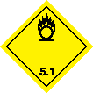
Transport Supplementary Class | 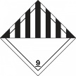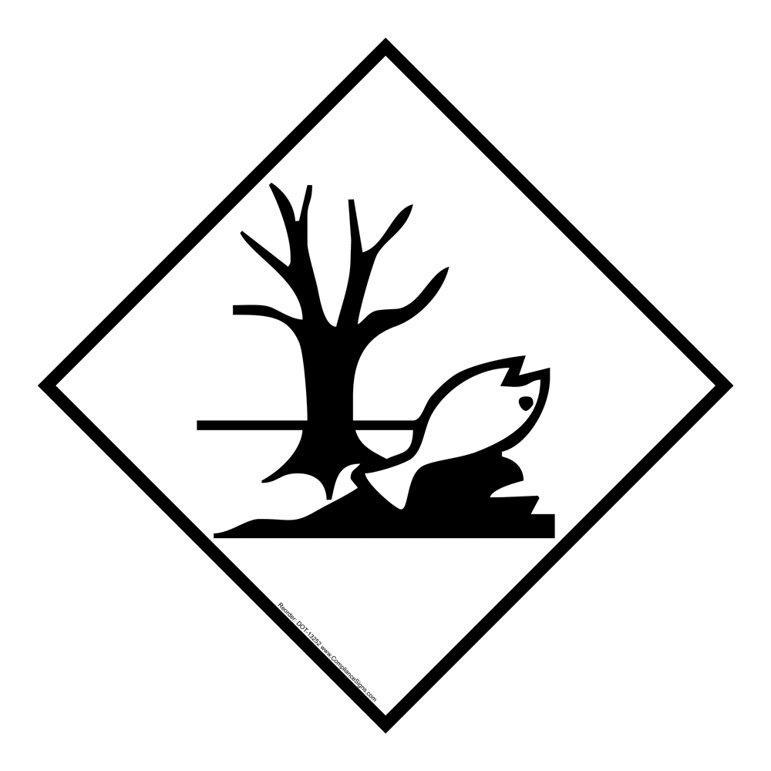
Packaging Group | III | III | III | III
Environmental Hazard | YES | YES | Marine Pollutant | YES

- Regulatory information

Safety, health, and environmental regulations specific for the product in question

Hazard symbol
Classification: | O - Oxidising  Xi – Irritant  N – Dangerous for the Environment
Risk phrases: | R8: Contact with combustible material may cause fire.  R36: Irritating to eyes.  R37: Irritating to the respiratory system.  R38: Irritating to skin.  R51: Very toxic to aquatic organisms.

Key to Abbreviations

AND | European Provisions concerning the International Carraige od Dangerous Goods by inland Waterways
ADR | The European Agreement concerning the International Carraige of Dangerous Goods by Road
ATE | Acute Toxicity Estimate
CAS Number | Chemical Abstracts Service Number
COD | Chemical Oxygen Demand
GHS | Globally Harmonised System of Classification and Labelling of Chemicals
IATA | International Air Transport Association
ICAO | International Civil Aviation Organisation
IMDG | International Maritime Dangerous Goods
Log_{Pow} | Logarithm of the octanol/water partition coefficient
LD₅₀ | Lethal Dose 50
LC₅₀ | Lethal Concentration 50
RID | The Regulations concerning the International Carraige of Dangerous Goods by Rail
SDS | Safety Data Sheet
STOT | SpecificTarget Organ Toxicity
TWA | Time Weighted Average
UN | United Nations

No known specific country national and/or local regulations applicable to the product (including its ingredients). A summary of the South African general laws/regulations are supplied below.

Country Specific Legal Requirements

Country | Requirements
South Africa: | Registration Requirements: Fertilizer, Farm Feeds, Agricultural Remedies and Stock Remedies Act, 1947 (Act 36 of 1947).  Pesticide Handling, Storage and Disposal Safety: SANS 10206: 2020.  Safety Data Sheet and Occupational Exposure Limit Requirements: Regulations for Hazardous Chemical Agents – 2021 – SA Occupational Health and Safety Act. SANS11014:2010.  Control of and handling of poisonous/hazardous and non-poisonous/non-hazardous substances/chemicals in workplaces: Hazardous Substances Act, 1973 (Act No.15 of 1973). Occupational Health and Safety Act No. 85 of 1993.

- Other information

Date of issue: | 18 September 2023
Date of previous issue: | June 2017
Version: | 3
Prepared by: | Hygrotech Sustainable Solutions

Notice to the reader
The information supplied in this Safety Data Sheet is correct to the best of our knowledge and belief at the time and date of its publication. Al reasonable effort was done to ensure that the data used is current and reliable. Neither the above-named supplier nor any of its subsidiaries assume any liability whatsoever for the accuracy or completeness of the information contained herein.
The information is supplied has been developed only as guidance for the safe handling, use, processing, storage, transportation, and disposal of the product and is not considered a warranty or quality specification. Final determination of suitability of any material is the sole responsibility of the user. All materials may present unknown hazards and should be used with caution. Although certain hazards are described herein, we cannot guarantee that these are the only hazards that exist.

END OF SAFETY DATA SHEET
Updated and revised: October 2025

