

Safety Data Sheet
Revision Date: 2023-08-02
- Product and company identification
Product Name: HYGROPONIC
Identification: Nutrient mixture
Recommended use: Fertilizer, only use as directed
Details of Supplier:
Hygrotech Properties (Pty) Ltd, 1 Gerard Braak Street, Pyramid, Pretoria, 0120
Emergency Telephone numbers:
Griffon Poison Information Centre: 082 446 8946
Hygrotech Head Office: 012 545 8000 (o/h)
- Hazard(s) identification
Classification of the substance or mixture
This product is classified as hazardous according to the criteria in South Africa - GHS classification and labelling of chemicals – SANS10234 and the Regulations for Hazardous Chemical Agents - 2021.

GHS Classification

Hazard Class | Category | Hazard Statement Number
Serious Eye Damage/Irritation | 2 | H319

Label Elements

Pictograms:
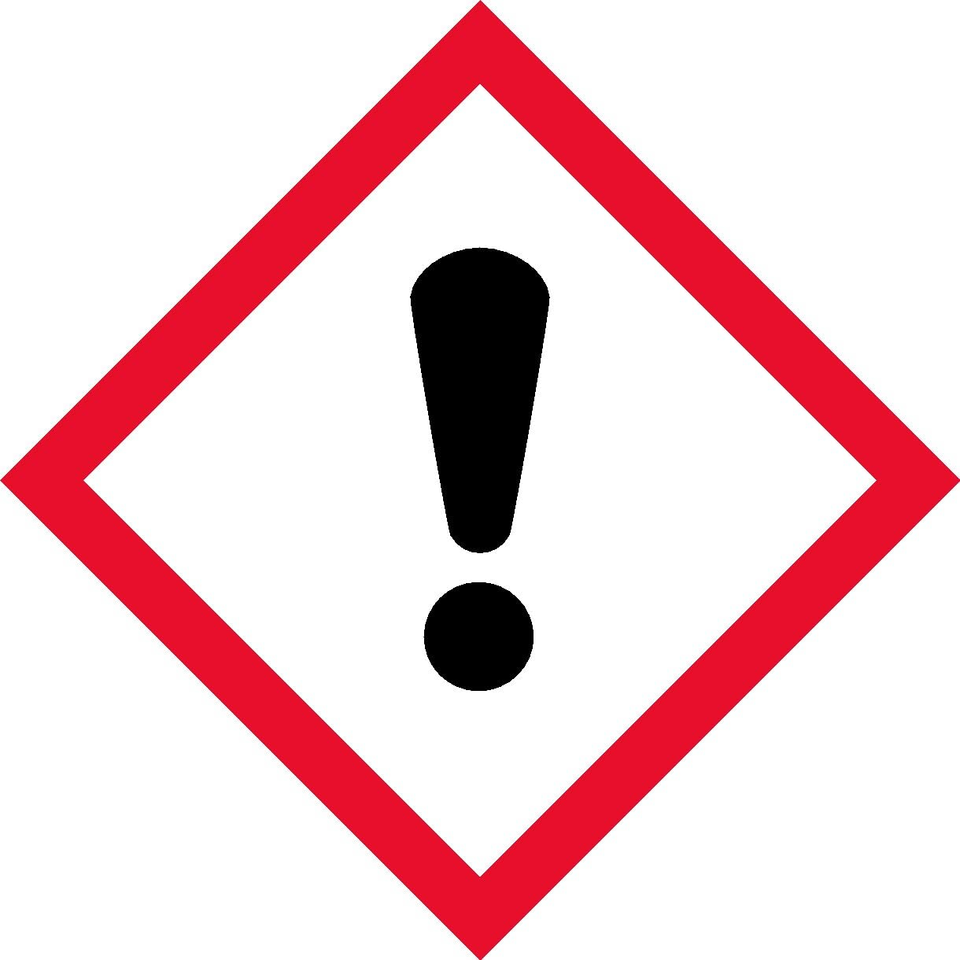

Signal Word:
Warning

Hazard Statements:

Statement Number | Hazard Statement
H319 | Causes serious eye irritation.

Precautionary Statements:
General -
Statement Number | Precautionary Statement
P101 | If medical advice is needed, have product container or label at hand.
P102 | Keep out of reach of children.
P103 | Read carefully and follow all instruction.

Prevention -
Statement Number | Precautionary Statement
P280 | Wear protective gloves, protective clothing, eye and face protection.
P264 + P265 | Wash hands and face thoroughly after handling.

Response -
Statement Number | Precautionary Statement
P337 + P317 | If eye irritation persists: Get medical help.
P305 + P351 + P338 | IF IN EYES: Rinse cautiously with water for several minutes. Remove contact lenses, if present and easy to do. Continue rinsing.

Other Hazards
None known for the product.

- Composition/information on ingredients
Substance/mixture
Mixture.

Ingredients with Hazard Concerns (GHS)
According to UN GHS criteria.

Hazardous Component – Chemical Name | CAS Number | Weight - % | GHS Classification
Potassium hydrogen sulphate | 7646-93-7 | <5% | Serious Eye Damage/Irritation Category 1.

NOTE: The other ingredients do not cause or contrinute toward the correct GHS classification of HYGROPONIC and are therefore, in terms of the South African Regulations for Hazardous Chemical Agents - 2021; Regulation 14(b), not listed in the table above.

- First Aid measures
Description of First Aid measures
General advice | In case of treatment resulting from excessive exposure, provide this SDS and product label to medical personnel. Emergency personnel should wear protective clothing appropriate to the type and degree of contamination. First Aid personnel should pay attention to their own safety.  Immediately remove contaminated clothing and move the affected person away from the contamination area. Keep the person warm, calm, and covered up.
Inhalation | Allow the patient to rest in a well-ventilated area. If breathing is difficult, have qualified personnel administer oxygen. If breathing has stopped, use artificial respiration to support vital functions. Remove and isolate contaminated clothing and shoes. Make sure medical personnel are aware of the substance involved and take precaution to protect them. Obtain medical attention if concerned or unwell.
Ingestion | If this product is swallowed, call a poison control centre or medical practitioner for treatment advice. If conscious, rinse mouth thoroughly with water. Never give anything by mouth to an unconscious or convulsing person. Do not induce vomiting unless directed to do so by a medical professional. Have the patient lean forward with head down to avoid breathing in of vomits if spontaneous vomiting occurs.
Skin contact | Remove all contaminated clothing and shoes. Decontaminate the affected skin area with running water under the safety shower. Minimum recommended flushing time is 15 – 20 minutes, especially if an adverse skin reaction occurs. Obtain medical attention if irritation occurs or persist. Contaminated clothing should be washed prior to re-use.
Eye contact | IMMEDIATELY rinse/flush the eyes gently with running water for at least 15 minutes keeping the eyelids apart. Cold water must be used. Check for and remove contact lenses if easy to do so. Continue with the rinsing. Prevent rubbing of the eyes. If irritation occurs or persists, obtain medical attention.

Most important symptoms/effects, acute and delayed
Skin irritation in sensitive individuals and serious eye irritation.
There may be irritation and redness at the site of contact. Eye may water profusely.
Irritation of the nose and throat if excessive amounts of dust is inhaled.
Ingestion of the product may cause nausea and vomiting.

Indication of any immediate medical attention and special treatment needed
Notes to physician:
No specific antidote required. Treat patient symptomatically and supportively.

- Fire-fighting measures

Fire Extinguishing Media | Small fires – the use of water spray is preferred. Carbon dioxide, foam, or dry chemicals only if water is not available.  Larger fires – use water fog or water spray.  Fire water must be contained for safe disposal.  Do not use high volume water jets due to potential contamination.
Specific hazards arising from the chemical including thermal decomposition products | Product is non-flammable.  When involved in a fire and exposed to extremely high temperatures, the components of this product may decompose to produce irritating vapours and hazardous compounds including oxides of carbon (CO and CO₂), nitrogen, potassium, sulphur (SO_{x}), magnesium, and phosphorous, as well as ammonia.
Special protective equipment | Fire responders should wear emergency equipment including positive pressure self-contained breathing apparatus with a full-face mask. If possible, prevent runoff water from entering storm drain bodies of water or other environmentally sensitive areas.
Additional measures | Fight the fire from a maximum distance and keep containers cool by spraying with water.  Act in accordance with the site’s Internal Emergency Plan and the procedures for actions to be taken during and after an accident or other emergencies.
- Accidental release measures

Personal precautions, protective equipment, and emergency procedures | In case of a release, clear the affected area and protect people. Appropriately trained personnel dressed in the prescribed personal protective equipment should respond to uncontrolled releases. Emergencies should be handled in accordance with the facility’s pre-planned procedures.  Contain the spill if it can be done without risk and clean-up immediately. Avoid sources of ignition in the spill area.  Ventilate the area of the spill or leak, especially when in confined areas and do not breathe in dust. Avoid contact of spilt material with eyes, skin and clothes and do not touch or walk through spilled material.  Wear appropriate protective clothing recommended in Section 8 of the SDS.
Environmental precaution | Prevent spillage or further leakage (if safe to so) and the contamination of environmentally sensitive areas.  Do not allow the spilt product to enter water courses and drains and avoid contact with soil.  Report spills and releases as required to appropriate authorities if the spilt product has caused environmental pollution (sewers, water ways, or soil).
Containment and clean-up | For small spills – clean up using gloves, safety glasses and appropriate body protection. Sweep/vacuum up and place into a labelled waste container with a shovel. Dispose of the spilt material to an approved hazardous waste facility.  For large spills - personal protective equipment should be level C: triple gloves, chemical resistant suit, and air purifying respirator with a high-efficiency particulate filter.  Prevent dust formation by covering with a tarpaulin. Contain and collect spilt product in suitable, labelled containers for proper disposal as hazardous waste.  If spill is in water, contain contaminated water for disposal as hazardous waste.
Reference to other SDS sections | See Section 1 for emergency contact information.  See Section 8 for information on appropriate personal protective equipment.  See Section 13 for additional waste treatment information.

- Handling and storage

Precautions for safe handling | Wear the protective clothing as indicated in Section 8 of this SDS. Prevent personal exposure to the product – prevent skin and eye contact. Wash hands and face thoroughly after handling the product and do not eat, drink, smoke or apply cosmetics while handling. Always use in a well- ventilated work area.  Locate emergency showers and eye-rinsing facility near the work/handling area. Maintain good normal industrial hygiene and housekeeping practices in areas where the product is used/handled.  Remove contaminated clothing immediately if the product gets inside. Contaminated work clothing should not be allowed out of the workplace. Regular cleaning of work area and work clothing is recommended.  Keep unprotected persons away from the area where the product is being applied.
Conditions for safe storage, including any incompatibilities | The entrance to storage facilities should be granted only to appropriately trained personnel. Keep out of reach of children, uninformed persons, and animals. Containers must always be clearly labelled and tightly closed/sealed when not in use. Store containers in a cool dry location, away from direct sunlight and sources of intense heat, or where freezing is possible.  Inspect all incoming containers before storage to ensure that containers are properly labelled and are not damaged.  Empty containers should be handled with care.  It is recommended to have appropriate spill control kits equipped with clean-up tools near storage areas (see Section 6).  Store in accordance with national and local regulations.  Store away from incompatible materials like combustible materials, reducing agents, organic compounds, and strong acids.

- Exposure controls/personal protection

Components with workplace control parameters – National Occupational Exposure Limits

An occupational exposure limit for acetylsalicylic acid (present in a small quantity) has been established by the South African Department of Labour and Employment.

Component | Type | Control Parameter | Update | Basis
Acetylsalicylic acid | OEL- eight- hour TWA | 10 mg/m³ | 2021 | South African RELs*

*REL: | Recommended Exposure Limit.
OEL- eight-hour TWA: | Occupational Exposure Limit- Time Weighted Average. Calculated over an eight-hour working day, for a five-day working week.

Appropriate engineering controls | Use with adequate general or mechanical exhaust ventilation to prevent inhalation of dust and to maintain airborne concentrations as low as possible and below the occupational exposure limit. Eyewash stations and safety showers should be near areas where this product is used, mixed, or sprayed.
Individual protection measures | Hand: impervious chemical resistant gloves recommended for hand protection (e.g., butyl rubber, nitrile rubber, etc.). The gloves should be replaced immediately in case of damage or signs of wear.  Eye/Face: safety eyewear compliant with an approved standard should be used when a risk assessment indicates this is necessary to avoid eye exposure to liquids and splashes. Safety goggles together with a face shield is recommended.  Skin: impervious overalls, apron, shoes, and socks as required to prevent skin contact and contamination of personal clothing. Overalls must be buttoned to the neck and sleeves worn over the gloves.  Respiratory: protection selection must be based on known or anticipated exposure levels, the hazards of the product and the safe working limits of the selected respiratory equipment.  In operations where exposure is expected to be high, excessive dust is generated, or where discomfort is experienced, a dust mask (FFP3) is recommended.  For emergency conditions, use an approved positive-pressure self-contained breathing apparatus.
Environmental exposure controls | In accordance with the national and local legislation for the protection of the environment, it is recommended to avoid environmental spillage or releases of both the product and its container.

- Physical and chemical properties

Phase | Solid - powder
Colour | No data available
Odour | Odourless
pH (1%) | 3-4
Relative density | 1 kg/L
Solubility | Soluble in water
Octanol/water partition coefficient: | No data available
Flash Point (°C) | No data available
Flammability | Not flammable

Other Hazard Information
None known for the product.

- Stability and reactivity

Reactivity: | The product is not reactive under normal ambient and anticipated storage and handling conditions of temperature and pressure.
Chemical stability: | Hazardous polymerization will not occur. Stable under normal ambient conditions of use, storage, and transport.
Conditions to avoid: | Storage without good ventilation, ignition sources (e.g. hot surfaces, open flames. etc.), contact with combustible materials, and exposing to excessive heat.
Incompatible materials: | Combustible materials, reducing agents, organic compounds, and strong acids.
Hazardous decomposition products: | Does not decompose when used for intended uses. Could decompose to produce irritating vapours and hazardous compounds including oxides of carbon (CO and CO₂), potassium, sulphur (SO_{x}), magnesium, and phosphorous, as well as ammonia.

- Toxicological information
Information on likely routes of exposure
The product can be absorbed into the body by inhalation of its aerosol/spray and by skin/eye contact.

Information on toxicological effects
Hygroponic is of low acute toxicity.

Assessment of acute toxicity:
Experimental toxicological test data are not available for the product. Assessment of acute toxicity is based on the ingredients.

Acute Toxicity Oral: The product is not classified.
Acute Toxicity Dermal: The product is not classified.
Acute Toxicity Inhalation: The product is not classified.

Irritation Dermal/Skin and Eyes: | Assessment of irritation effects (skin/eyes):  Based on available data, the classification criteria are met for serious eye irritation.  Potassium hydrogen sulphate: Irritating to the yes. Rabbit – OECD Guideline 405. Data source: ECHA.
Corrosion Skin/Serious Eye Damage: | Assessment of skin corrosion/serious eye damage:  Based on available data, the classification criteria are not met.
Respiratory/Skin Sensitization: | Assessment of sensitization:  Based on available data, the classification criteria are not met.
Germ Cell Mutagenicity: | Assessment of mutagenicity:  Based on available data, the classification criteria are not met.
Carcinogenicity: | Assessment of carcinogenicity:  Based on available data, the classification criteria are not met.
Reproductive Toxicity and Developmental Toxicity: | Assessment of reproduction toxicity:  Based on available data, the classification criteria are not met.
Specific Target Organ Toxicity (Single Exposure): | Assessment of STOT (single):  Based on available data, the classification criteria are not met.
Specific Target Organ Toxicity (Repeated Exposure): | Assessment of repeated dose toxicity:  Based on available data, the classification criteria are not met.
Aspiration Hazard: | Assessment of repeated dose toxicity:  Based on available data, the classification criteria are not met.
Delayed and immediate effects as well as chronic effects from short and long-term exposure
The delayed, immediate, and chronic effects of the product are discussed in Section 4 of the SDS.

- Ecological information
Ecotoxicity
The product is of low toxicity to aquatic systems.
The product will not enter the environment under normal conditions if used as indicated on the label. Care should however be taken to avoid any additional release, for example through inappropriate disposal.
No eco-toxicological data are available for the formulated product. This ecological assessment is based on data available for the ingredients.
Other Environmental and Adverse Effects:

Persistence and degradability:
No data available for the product.

Bioaccumulative potential:
No data available for the product.

Mobility in soil:
The product is soluble in water and is expected to be leachable through normal soil.

Other adverse effects:
No known for the product.

- Disposal information

Waste handling and disposal methods: | Rinse empty container 3 times with a volume of water equal to one tenth of the volume of the container and add to the spray tank.  Avoid and minimize the generation of waste.  Dispose product related waste in accordance with all local regulations and prevent the contamination of water, food, or feed by storage or disposal of the waste. Waste product or empty containers must not be disposed of as part of general waste.
Disposal of packaging: | The product and its container must always be disposed of in a safe manner. Empty containers and offer for recycling if an available option.  Recondition if appropriate, or puncture/flatten and dispose of in a hazardous waste landfill, or by other procedures approved by the local authorities.

- Transport information
The product is not classified for the transport of Dangerous Goods purposes.
- Regulatory information
Safety, health, and environmental regulations specific for the product in question

Hazard symbol
Classification: | Xi – Irritant.
Risk phrases: | R36: Irritating to eyes.

Key to Abbreviations

AND | European Provisions concerning the International Carraige od Dangerous Goods by inland Waterways
ADR | The European Agreement concerning the International Carraige of Dangerous Goods by Road
ATE | Acute Toxicity Estimate
CAS Number | Chemical Abstracts Service Number
COD | Chemical Oxygen Demand
GHS | Globally Harmonised System of Classification and Labelling of Chemicals
IATA | International Air Transport Association
ICAO | International Civil Aviation Organisation
IMDG | International Maritime Dangerous Goods
Log_{Pow} | Logarithm of the octanol/water partition coefficient
LD₅₀ | Lethal Dose 50
LC₅₀ | Lethal Concentration 50
RID | The Regulations concerning the International Carraige of Dangerous Goods by Rail
SDS | Safety Data Sheet
STOT | SpecificTarget Organ Toxicity
TWA | Time Weighted Average
UN | United Nations

No known specific country national and/or local regulations applicable to the product (including its ingredients). A summary of South African general laws/regulations are supplied below.

Country Specific Legal Requirements

Country | Requirements
South Africa: | Registration Requirements: Fertilizer, Farm Feeds, Agricultural Remedies and Stock Remedies Act, 1947 (Act 36 of 1947).  Pesticide Handling, Storage and Disposal Safety: SANS10206: 2020.  Safety Data Sheet and Occupational Exposure Limit Requirements: Regulations for Hazardous Chemical Agents – 2021 – SA Occupational Health and Safety Act. SANS11014:2010.  Control of and handling of poisonous/hazardous and non-poisonous/non-hazardous substances/chemicals in workplaces: Hazardous Substances Act, 1973 (Act No.15 of 1973). Occupational Health and Safety Act No. 85 of 1993.

- Other information

Date of issue: | 2 August 2023
Date of previous issue: | June 2017
Version: | 2
Prepared by: | Hygrotech Sustainable Solutions

Notice to the reader
The information supplied in this Safety Data Sheet is correct to the best of our knowledge and belief at the time and date of its publication. Al reasonable effort was done to ensure that the data used is current and reliable. Neither the above-named supplier nor any of its subsidiaries assume any liability whatsoever for the accuracy or completeness of the information contained herein.
The information is supplied has been developed only as guidance for the safe handling, use, processing, storage, transportation, and disposal of the product and is not considered a warranty or quality specification. Final determination of suitability of any material is the sole responsibility of the user. All materials may present unknown hazards and should be used with caution. Although certain hazards are described herein, we cannot guarantee that these are the only hazards that exist.

END OF SAFETY DATA SHEET
Updated and revised: October 2025

