

Safety Data Sheet
Revision Date: 2025-12-01
- Product and company identification
Product Name: Dripfeed.
Identification: Fertilizer – for drip feeding or foliar irrigation.
Recommended use: Fertilizer, only use as directed.
Details of Supplier:
Hygrotech Properties (Pty) Ltd, 1 Gerard Braak Street, Pyramid, Pretoria, 0120.
Emergency Telephone numbers:
Griffon Poison Information Centre: 082 446 8946.
Hygrotech Head Office: 012 545 8000 (o/h).

- Hazard(s) identification
Classification of the substance or mixture
This product is classified as hazardous according to the criteria in South Africa - GHS classification and labelling of chemicals – SANS10234 and the Regulations for Hazardous Chemical Agents - 2021.

GHS Classification

Hazard Class | Category | Hazard Statement Number
Reproductive Toxicity | 1B | H360FD

Label Elements

Pictogram:
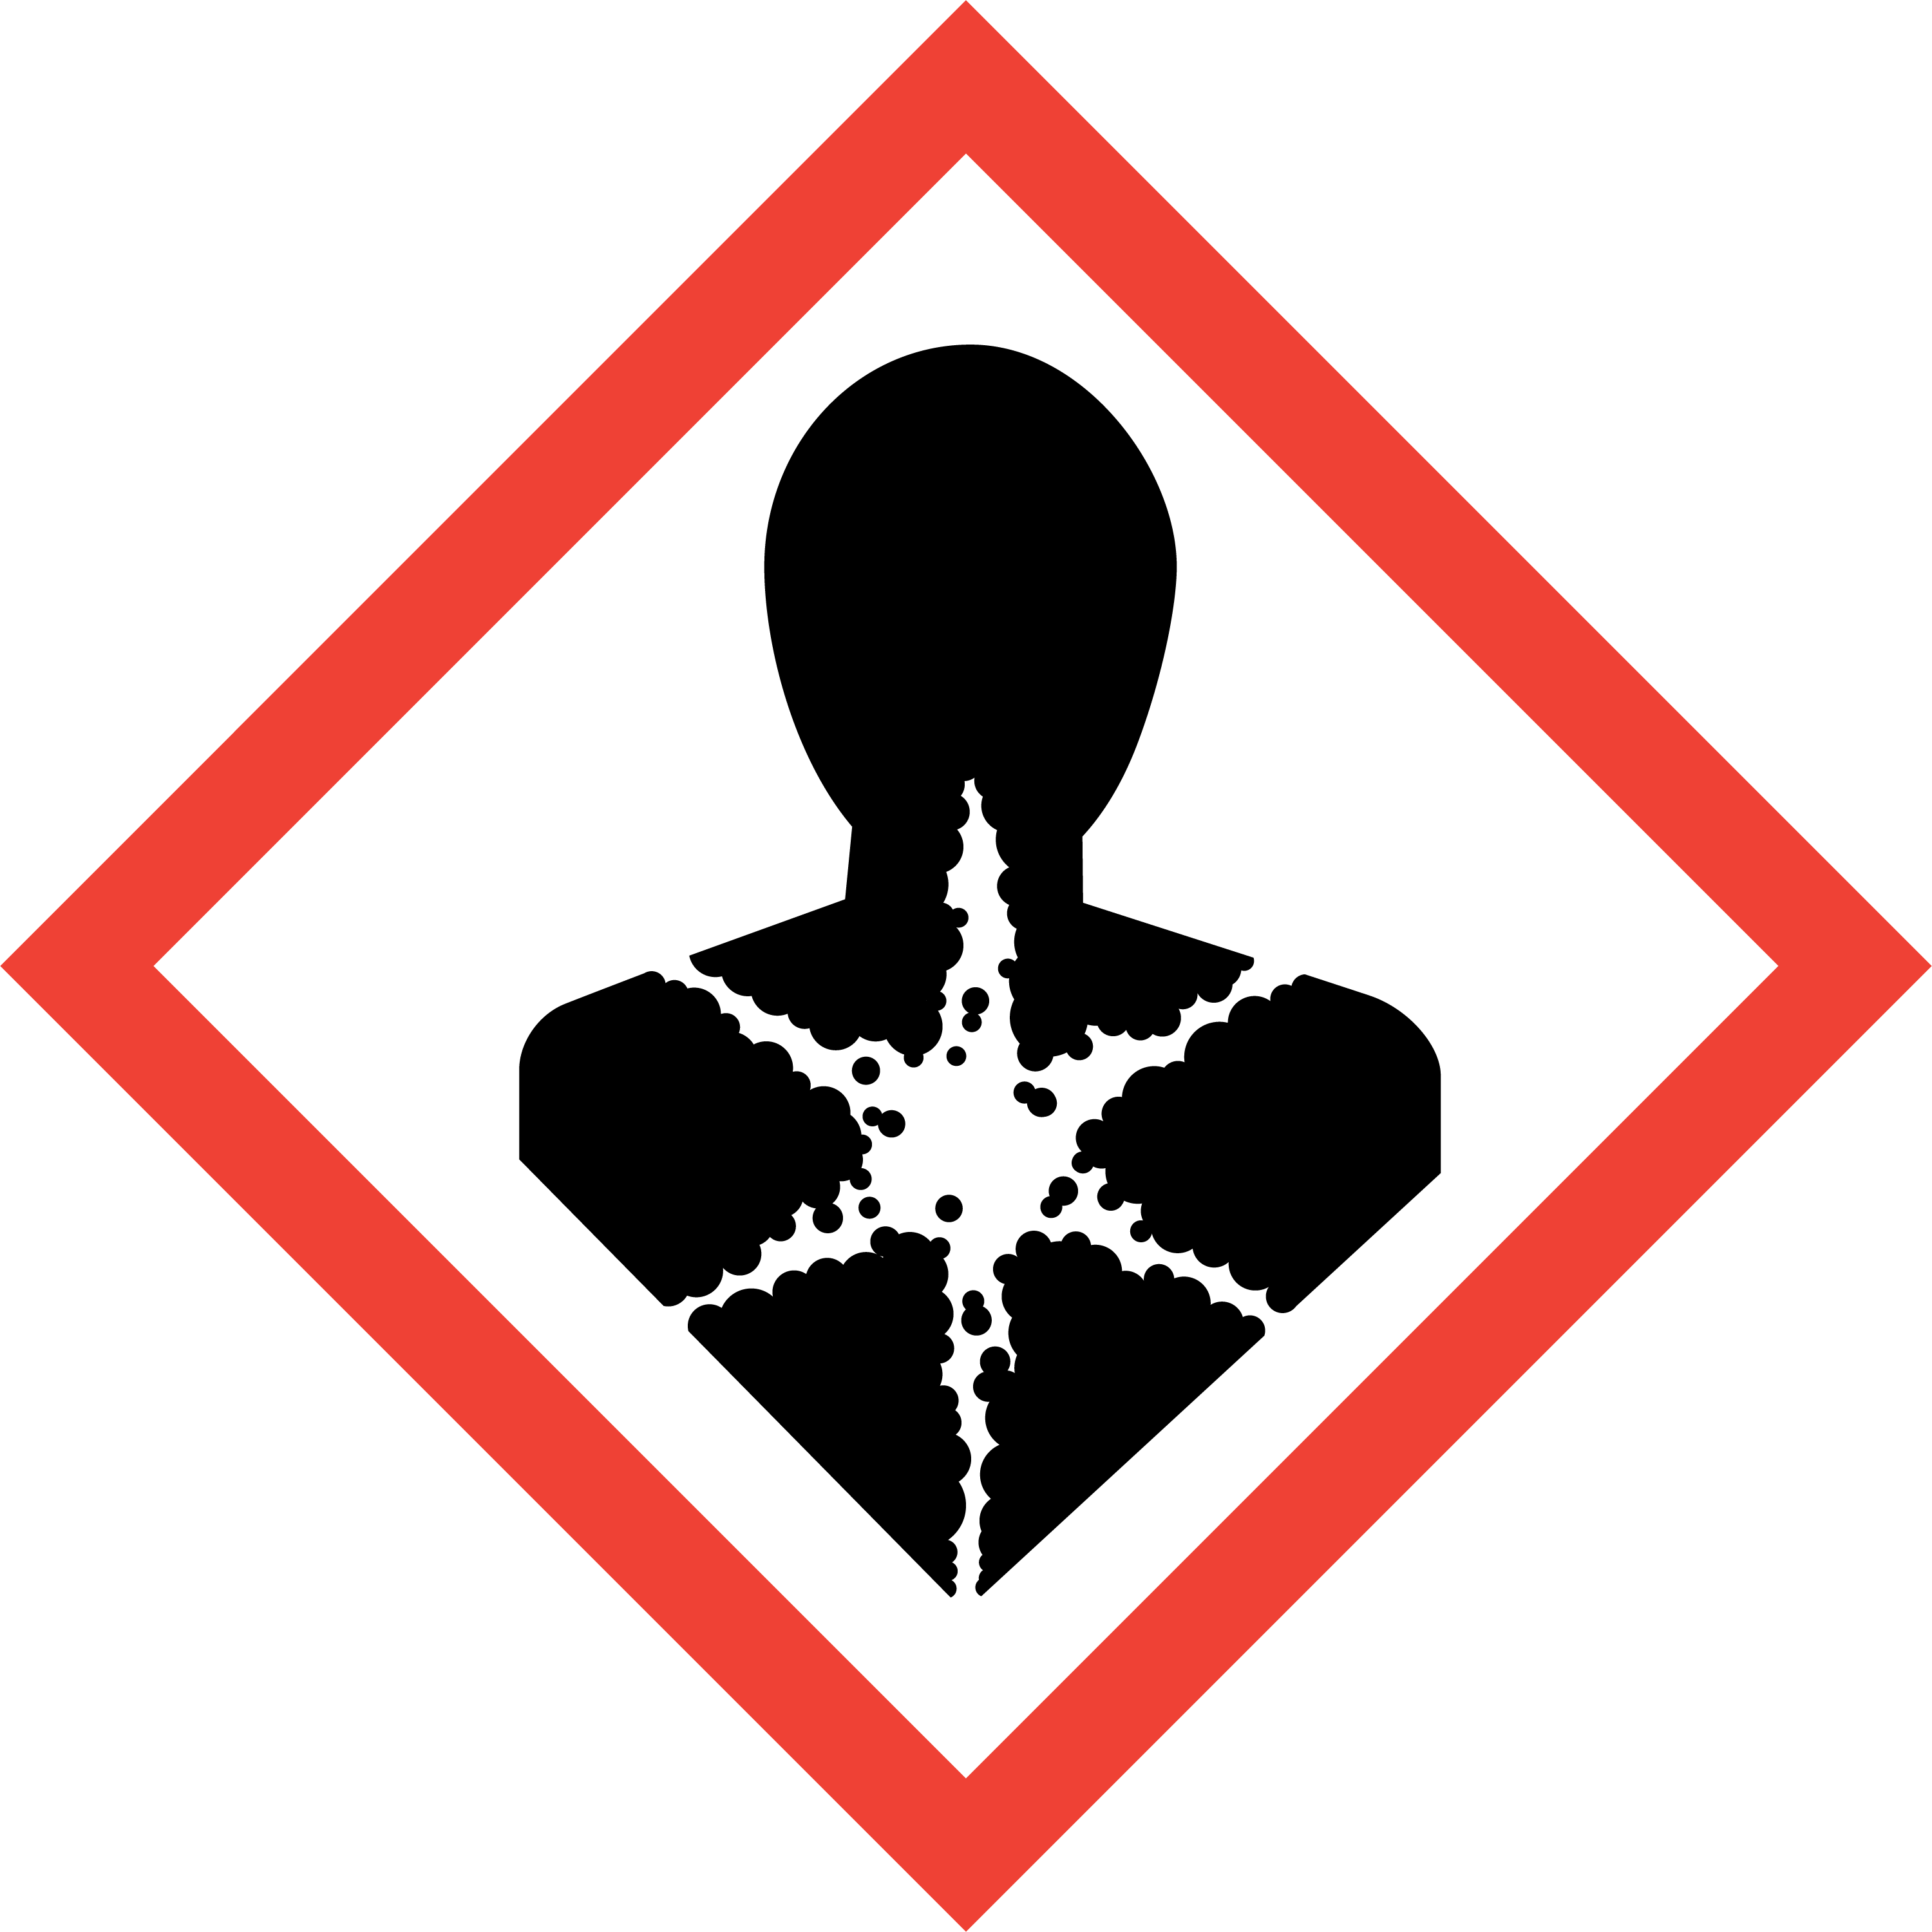

Signal Word:
Danger

Hazard Statements:

Statement Number | Hazard Statement
H360FD | May damage fertility. May damage the unborn child.

Precautionary Statements:
General -
Statement Number | Precautionary Statement
P101 | If medical advice is needed, have product container or label at hand.
P102 | Keep out of reach of children.

Prevention -
Statement Number | Precautionary Statement
P203 | Obtain, read, and follow all safety instructions before use.
P280 | Wear protective gloves, protective clothing, eye and face protection.

Response -
Statement Number | Precautionary Statement
P318 | IF exposed or concerned, get medical help.

Storage -
Statement Number | Precautionary Statement
P405 | Store locked up.

Disposal -
Statement Number | Precautionary Statement
P501 | Dispose of contents/container according to local and national regulations to a licensed hazardous waste facility.

Other Hazards
None known for the product.

- Composition/information on ingredients
Substance/mixture
Mixture.

Major ingredients including those with hazard concerns (GHS)
According to UN GHS criteria.

Hazardous Component – Chemical Name | CAS Number | Weight - % | GHS Classification
Potassium nitrate | 7757-79-1 | 40 – 50% | Oxidising Solid, Category 3.
Monoammonium phosphate | 7722-76-1 | 30 – 40% | Not GHS classified
Urea | 57-13-6 | 20 – 30% | Not GHS classified
Disodium octaborate  tetrahydrate | 12280-03-4 | <1% | Reproductive Toxicity, Category 1B.

NOTE: The other ingredients do not cause or contrinute toward the correct GHS classification of Dripfeed and are therefore, in terms of the South African Regulations for Hazardous Chemical Agents - 2021; Regulation 14(b), not listed in the table above.

- First Aid measures
Description of First Aid measures
General advice | In case of treatment resulting from excessive exposure, provide this SDS and product label to medical personnel. Emergency personnel should wear protective clothing appropriate to the type and degree of contamination. First Aid personnel should pay attention to their own safety. Immediately remove contaminated clothing and move the affected person away from the contamination area. Keep the person warm, calm, and covered up.
Inhalation | Allow the patient to rest in a well-ventilated area. If breathing is difficult, have qualified personnel administer oxygen. If breathing has stopped, use artificial respiration to support vital functions. Remove and isolate contaminated clothing and shoes. Make sure medical personnel are aware of the substance involved and take precaution to protect them. Obtain medical attention if concerned or unwell.
Ingestion | If this product is swallowed, call a poison control centre or medical practitioner for treatment advice. If conscious, rinse mouth thoroughly with water. Never give anything by mouth to an unconscious or convulsing person. Do not induce vomiting unless directed to do so by a medical professional. Have the patient lean forward with head down to avoid breathing in of vomits if spontaneous vomiting occurs.
Skin contact | Remove all contaminated clothing and shoes. Decontaminate the affected skin area with running water under the safety shower. Minimum recommended flushing time is 15 – 20 minutes, especially if an adverse skin reaction occurs. Obtain medical attention if irritation occurs or persist. Contaminated clothing should be washed prior to re-use.
Eye contact | Rinse/flush the eyes gently with running water for at least 15 minutes keeping the eyelids apart. Cold water must be used. Check for and remove contact lenses if easy to do so. Continue with the rinsing. Prevent rubbing of the eyes. If irritation occurs or persists, obtain medical attention.

Most important symptoms/effects, acute and delayed
Skin and eyes: May cause mild irritation after repeated exposure in sensitive individuals. Direct eye contact may cause the eyes to water profusely. In case of repeated skin contact there may be temporary irritation and redness at the site of contact.
Inhalation: Irritation of the nose and throat if excessive amounts of dust is inhaled.
Ingestion: May cause nausea and vomiting.
Reproductive toxicity effects: Studies in animals in several species have indicated that borates cause developmental and reproductive effects.

Indication of any immediate medical attention and special treatment needed
Notes to physician:
No specific antidote required. Treat patient symptomatically and supportively.

- Fire-fighting measures

Suitable (and unsuitable) extinguishing media | Small fires – use water spray, carbon dioxide, foam, or dry chemicals.  Larger fires – use foam, water fog or water spray.  Fire water must be contained for safe disposal.  Do not use high volume water jets due to potential contamination.
Specific hazards arising from the chemical including thermal decomposition products | The product is non-flammable. When involved in a fire and exposed to extremely high temperatures, the components of this product may decompose to produce irritating vapours and hazardous compounds.  Decomposition products may including oxides of nitrogen (NO_{x}), carbon (CO and CO₂), phosphorous, and potassium as well as ammonia.
Special protective equipment | Fire responders should wear emergency equipment including positive pressure self-contained breathing apparatus with a full-face mask. If possible, prevent runoff water from entering storm drain bodies of water or other environmentally sensitive areas.
Additional measures | Fight the fire from a maximum distance and keep containers cool by spraying with water.  Act in accordance with the site’s Internal Emergency Plan and the procedures for actions to be taken during and after an accident or other emergencies.

- Accidental release measures

Personal precautions, protective equipment, and emergency procedures | In case of a release, clear the affected area and protect people. Appropriately trained personnel dressed in the prescribed personal protective equipment should respond to uncontrolled releases. Emergencies should be handled in accordance with the facility’s pre-planned procedures.  Contain the spill if it can be done without risk and clean-up immediately. Avoid sources of ignition in the spill area.  Ventilate the area of the spill or leak, especially when in confined areas and do not breathe in dust/vapours. Avoid contact of spilt material with eyes, skin and clothes and do not touch or walk through spilled material.  Wear appropriate protective clothing recommended in Section 8 of the SDS.
Environmental precaution | Prevent spillage or further leakage (if safe to so) and the contamination of environmentally sensitive areas.  Do not allow the spilt product to enter water courses and drains and avoid contact with soil.  Report spills and releases as required to appropriate authorities if the spilt product has caused environmental pollution (sewers, water ways, or soil).
Containment and clean-up | For small spills – clean up using gloves, safety glasses and appropriate body protection. Sweep/vacuum up and place into a labelled waste container with a shovel. Dispose of the spilt material to an approved hazardous waste facility.  For large spills - personal protective equipment should be level C: triple gloves, chemical resistant suit, and air purifying respirator with a high-efficiency particulate filter.  Prevent dust formation by covering with a tarpaulin. Contain and collect spilt product in suitable, labelled containers for proper disposal as hazardous waste.  If spill is in water, contain contaminated water for disposal as hazardous waste.
Reference to other SDS sections | See Section 1 for emergency contact information.  See Section 8 for information on appropriate personal protective equipment.  See Section 13 for additional waste treatment information.

- Handling and storage

Precautions for safe handling | Wear the protective clothing as indicated in Section 8 of this SDS. Prevent personal exposure to the product – prevent skin and eye contact. Wash hands and face thoroughly after handling the product and do not eat, drink, smoke or apply cosmetics while handling. Always use in a well- ventilated work area.  Locate emergency showers and eye-rinsing facility near the work/handling area. Maintain good normal industrial hygiene and housekeeping practices in areas where the product is used/handled.  Remove contaminated clothing immediately if the product gets inside. Contaminated work clothing should not be allowed out of the workplace. Regular cleaning of work area and work clothing is recommended.  Keep unprotected persons away from the area where the product is being applied.
Conditions for safe storage, including any incompatibilities | The entrance to storage facilities should be granted only to appropriately trained personnel. Keep out of reach of children, uninformed persons, and animals. Containers must always be clearly labelled and tightly closed/sealed when not in use. Store containers in a cool dry location, away from direct sunlight and sources of intense heat/ignition.  Store away from incompatible materials like combustible materials, reducing agents, organic compounds, and strong acids.  Inspect all incoming containers before storage to ensure that containers are properly labelled and are not damaged.  Empty containers should be handled with care.  It is recommended to have appropriate spill control kits equipped with clean-up tools near storage areas (see Section 6).  Store in accordance with national and local regulations.

- Exposure controls/personal protection

Components with workplace control parameters – National Occupational Exposure Limits

Occupational exposure limits have not been established for any of the product’s ingredients by the South African Department of Employment and Labour. Occupational exposure limits for airborne dust and respirable dust have though been established as indicated below:

Component | Type | Control Parameter | Update | Basis
Total air borne dust | OEL- eight- hour TWA | 10 mg/cm³ | 2021 | South African RELs*
Total respirable dust | OEL- eight- hour TWA | 5mg/m³ | 2021 | South African RELs*

*REL: | Recommended Exposure Limit.
OEL- eight-hour TWA: | Occupational Exposure Limit - Time Weighted Average. Calculated over an eight-hour working day, for a five-day working week.

Appropriate engineering controls | Use with adequate general or mechanical exhaust ventilation to prevent inhalation of dust, spray, or mist and to maintain airborne dust concentration as low as possible.  Eyewash stations and safety showers should be near areas where this product is used or sprayed.
Individual protection measures | Hand: impervious chemical resistant gloves recommended for hand protection (e.g., butyl rubber, nitrile rubber, etc.). The gloves should be replaced immediately in case of damage or signs of wear.  Eye/Face: safety eyewear compliant with an approved standard should be used when a risk assessment indicates this is necessary to avoid eye exposure to dust and spray mist. Safety goggles recommended if a full-face respirator is not used.  Skin: impervious overalls, apron, shoes, and socks as required to prevent skin contact and contamination of personal clothing. Overalls must be buttoned to the neck and sleeves worn over the gloves.  Respiratory: In operations where the risk assessment indicates that there could be exposure e.g., when exposure to dust/spray mist is expected, when handling in an enclosed area or when prolonged exposure is possible, an approved respirator (full face mask) with a particulate filter and an organic vapour cartridge or supplied air respirator should be used.  Protection selection must be based on known or anticipated exposure levels, the hazards of the product and the safe working limits of the selected respiratory equipment.  For emergency conditions, use an approved positive-pressure self-contained breathing apparatus.
Environmental exposure controls | In accordance with the national and local legislation for the protection of the environment, it is recommended to avoid environmental spillage or releases of both the product and its container.

- Physical and chemical properties

Phase | Solid - powder
Colour | White
Odour | Odourless
pH (1%) | Not applicable - solid
Relative density | No data available
Solubility | Soluble in water
Octanol/water partition coefficient: | No data available
Flammability | Not flammable
Boiling point (°C) | Not applicable - solid

Other Hazard Information
None known for the product.

- Stability and reactivity

Reactivity | The product is not reactive under normal ambient and anticipated storage and handling conditions of temperature and pressure.
Chemical stability | Hazardous polymerization will not occur. Stable under normal ambient conditions of use, storage, and transport.
Conditions to avoid | Storage without good ventilation, exposing to excessive heat and combustible materials.
Incompatible materials | Combustible materials, reducing agents, organic compounds, and strong acids.
Hazardous decomposition products | Does not decompose when used for intended uses. Could decompose under fire or during burning and at high temperatures releasing oxides of nitrogen (NO_{x}), carbon (CO and CO₂), phosphorous, and potassium as well as ammonia.

- Toxicological information
Information on likely routes of exposure
The product can be absorbed into the body by inhalation of dust or aerosol and by skin/eye contact.

Information on toxicological effects
Dripfeed is of low acute toxicity and is not classified for oral, dermal or inhalation.

Assessment of acute toxicity:
Experimental toxicological test data are not available for the product. Assessment of acute toxicity is based on the ingredients.

Acute Toxicity Oral: The product is not classified.
Acute Toxicity Dermal: The product is not classified.
Acute Toxicity inhalation: The product is not classified.

Irritation Dermal/Skin and Eyes | Assessment of irritation effects (skin/eyes):  Based on available data, the classification criteria are not met.
Skin Corrosion/Eye Damage | Assessment of skin corrosion/eye damage:  Based on available data, the classification criteria are not met.
Respiratory/Skin Sensitization | Assessment of sensitization:  Based on available data, the classification criteria are not met.
Germ Cell Mutagenicity | Assessment of mutagenicity:  Based on available data, the classification criteria are not met.
Carcinogenicity | Assessment of carcinogenicity:  Based on available data, the classification criteria are not met.
Reproductive Toxicity and Developmental Toxicity | Assessment of reproduction toxicity:  Based on available data, the classification criteria are met.  Disodium octaborate tetrahydrate - Animal feeding studies in rats, mice, and dogs at high doses have demonstrated effects on fertility and the testes. Studies in rats, mice, and rabbits at high doses have demonstrated developmental effects on the foetus, including foetal weight loss and minor skeletal variations. The doses administered were many times more than those which humans would normally be exposed to. A recent epidemiology study under the conditions of normal occupational exposure to borate dusts indicated no effect on fertility.  Data sources:  - Weir R J, Fisher R S, Toxicol. Appl. Pharmacol., (1972), 23, 351-364.  - National Toxicology Program (NTP) – Technical Report Series No. TR324, NIH Publication No. 88-2580 (1987), PB88 213475/XAB.  - Fail et al., Fund. Appl. Toxicol. (1991) 17, 225-239.  - Heindel et al., Fund. Appl. Toxicol. (1992) 18, 266-277.
Specific Target Organ Toxicity (Single Exposure) | Assessment of STOT (single):  Based on available data, the classification criteria are not met.
Specific Target Organ Toxicity (Repeated Exposure) | Assessment of repeated dose toxicity:  Based on available data, the classification criteria are not met.
Aspiration Hazard | Assessment of repeated dose toxicity:  Based on available data, the classification criteria are not met.

Delayed and immediate effects as well as chronic effects from short and long-term exposure
None known for the product.

- Ecological information
Ecotoxicity
The product is of low toxicity to aquatic systems.
The product will not enter the environment under normal use if used as indicated on the label. Care should however be taken to avoid any additional release, for example through inappropriate disposal.
No eco-toxicological data are available for the formulated product.
Persistence and Degradability
No data available for the product.

Mobility in Soil
The product is soluble in water and is expected to be leachable through normal soil.

Bioaccumulative Potential
No significant bio-accumulative potential is expected for the product.

Other Environmental and Adverse Effects:
No specific data available for the product.

- Disposal information

Waste handling and disposal methods | Avoid and minimize the generation of waste.  Rinse empty container 3 times with a volume of water equal to one tenth of the volume of the container and add to the spray tank.  Dispose of product related waste in accordance with all local regulations and prevent the contamination of water, food, or feed by storage or disposal of the waste. Thermal treatment (if an available option) is recommended.  Waste product must not be disposed of as part of general waste.
Disposal of packaging | Non-refillable container - do not reuse for any purposes or refill the container.  Empty the container by triple rinsing. The empty containers must always be disposed of in a safe manner and in accordance with local and national regulations. Puncture and flatten (if practical) containers. Offer for recycling by taking the container to a collection point from where it can be removed by an approved service provider.

- Transport information
The product is not classified for the transport of Dangerous Goods purposes by rail or road.

- Regulatory information
Safety, health, and environmental regulations specific for the product in question

Hazard symbol
Classification | T: Toxic for reproduction.
Risk phrases | R62: Possible risk of impaired fertility.  R63: Possible risk of harm to the unborn child.

Key to Abbreviations

AND | European Provisions concerning the International Carraige od Dangerous Goods by inland Waterways
ADR | The European Agreement concerning the International Carraige of Dangerous Goods by Road
ATE | Acute Toxicity Estimate
CAS Number | Chemical Abstracts Service Number
COD | Chemical Oxygen Demand
GHS | Globally Harmonised System of Classification and Labelling of Chemicals
IATA | International Air Transport Association
ICAO | International Civil Aviation Organisation
IMDG | International Maritime Dangerous Goods
Log_{Pow} | Logarithm of the octanol/water partition coefficient
LD₅₀ | Lethal Dose 50
LC₅₀ | Lethal Concentration 50
RID | The Regulations concerning the International Carraige of Dangerous Goods by Rail
SDS | Safety Data Sheet
STOT | SpecificTarget Organ Toxicity
TWA | Time Weighted Average
UN | United Nations

No known specific country national and/or local regulations applicable to the product (including its ingredients). A summary of South African specific general laws/regulations are supplied below.

Country Specific General Legal Requirements

Country | Requirements
South Africa | Registration Requirements: Fertilizer, Farm Feeds, Agricultural Remedies and Stock Remedies Act, 1947 (Act 36 of 1947). Fertilizer, Farm Feeds, Agricultural Remedies and Stock Remedies Act, 1947 (Act No. 36 of 1947) Regulations Relating to Agricultural Remedy. 25 August 2023.  Safety Data Sheet and Occupational Exposure Limit Requirements: Regulations for Hazardous Chemical Agents – 2021 – SA Occupational Health and Safety Act. SANS11014:2010.  Control of and handling of poisonous/hazardous and non-poisonous/non-hazardous substances/chemicals in workplaces: Hazardous Substances Act, 1973 (Act No.15 of 1973). Occupational Health and Safety Act No. 85 of 1993.  Transportation of Dangerous Goods: National Road Traffic Act, 1996 (Act No. 93 of 1996). SANS 10228:2021- The identification and classification of dangerous goods for transport by road and rail modes.  Waste Management: National Environmental Management: Waste Act 59 of 2008.

- Other information

Date of issue | 23 September 2023
Date of previous issue | December 2014
Version | 2
Prepared by | Hygrotech Sustainable Solutions

Notice to the reader
The information supplied in this Safety Data Sheet is correct to the best of our knowledge and belief at the time and date of its publication. Al reasonable effort was done to ensure that the data used is current and reliable. Neither the above-named supplier nor any of its subsidiaries assume any liability whatsoever for the accuracy or completeness of the information contained herein. The information is supplied has been developed only as guidance for the safe handling, use, processing, storage, transportation, and disposal of the product and is not considered a warranty or quality specification. Final determination of suitability of any material is the sole responsibility of the user. All materials may present unknown hazards and should be used with caution. Although certain hazards are described herein, we cannot guarantee that these are the only hazards that exist.
END OF SAFETY DATA SHEET
Updated and revised: 2025-12-01

